Supplementary files
Table S1: Quality assessment of eligible studies (Newcastle-Ottawa Scale).
Study | Selection |  |  | Comparability |  |  | Outcome |  | Total
Study | Adequacy of case definition | Number  of case | Representativeness of the cases | Ascertainment of  relevant cancers | Ascertainment of  detection method | Cut-off | Assessment of outcome | Adequate  follow up | Total
Li et al.a | 1 | 0 | 1 | 1 | 1 | 1 | 1 | 1 | 7
Li et al. b | 1 | 1 | 1 | 1 | 1 | 1 | 1 | 1 | 8
Vasquez et al. | 1 | 0 | 1 | 1 | 1 | 1 | 1 | 1 | 7
Liu et al. | 1 | 1 | 1 | 1 | 1 | 1 | 1 | 1 | 8
Xia et al. | 1 | 1 | 1 | 1 | 1 | 1 | 1 | 1 | 8
Aggerholm-Pedersen et al. | 1 | 1 | 1 | 1 | 1 | 1 | 1 | 1 | 8

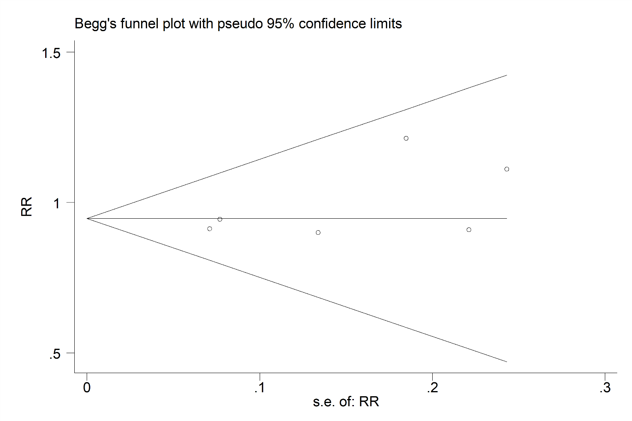
Figure S1: Begg’s funnel plot for NLR in patients with bone sarcomas.

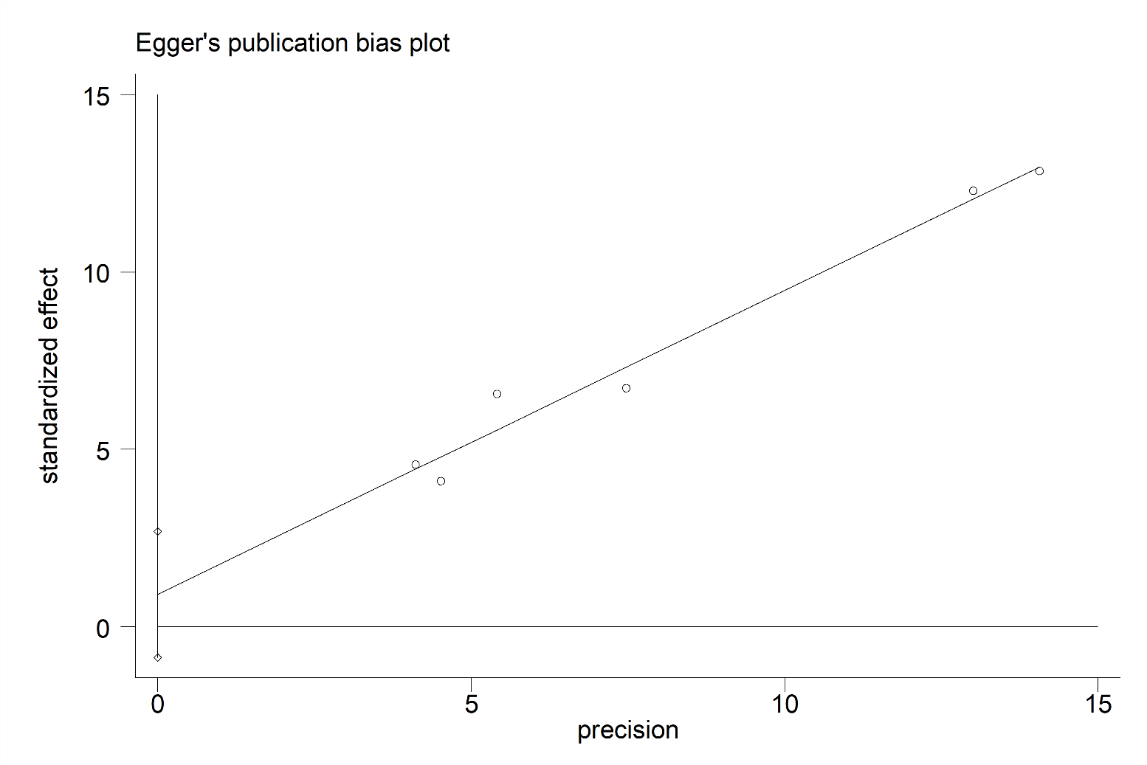
Figure S2: Egger’s funnel plot for NLR in patients with bone sarcomas.

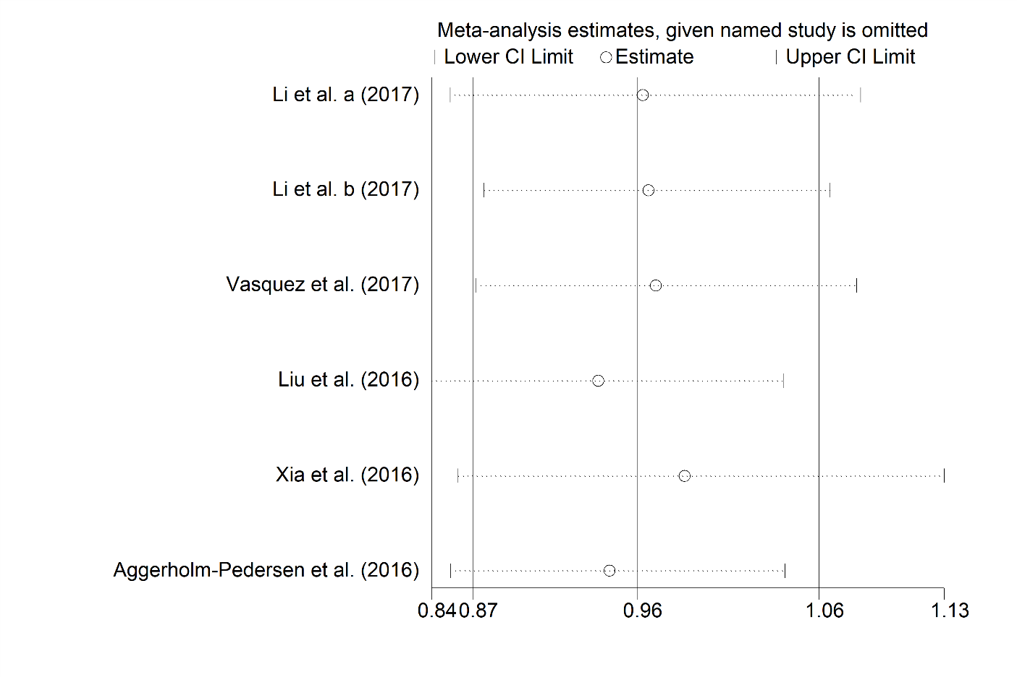
Figure S3: Sensitivity analysis for NLR in patients with bone sarcomas.

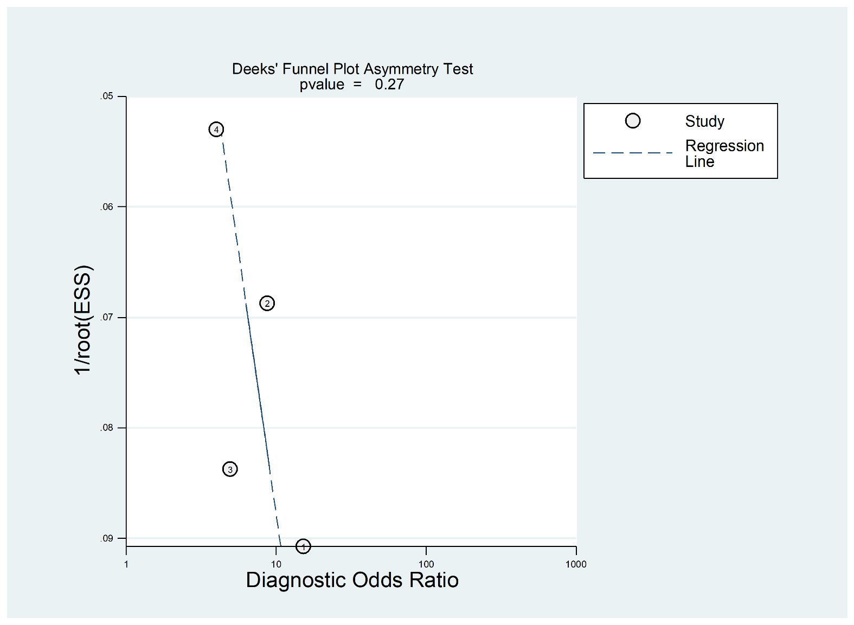
Figure S4: Deeks’ funnel plot asymmetry test for NLR in patients with bone sarcomas.

